Study Variation of Exponential function and Sinc function

% Define the x values for both ranges

x1 = linspace(0.01, 1, 500); % Avoid x=0 for sinc(x)

x2 = linspace(1.01, 5, 500); % Range for x > 1

% Calculate the exponential function values

exp_x1 = exp(x1);

exp_x2 = exp(x2);

% Calculate the sinc function values

sinc_x1 = sinc(x1); % sinc(x) in MATLAB is normalized: sinc(pi*x)/(pi*x)

sinc_x2 = sinc(x2);

% Plot for 0 < x < 1

subplot(2, 1, 1);

plot(x1, exp_x1, 'r', 'LineWidth', 2);

hold on;

plot(x1, sinc_x1, 'b', 'LineWidth', 2);

hold off;

grid on;

xlabel('x (0 < x < 1)');

ylabel('f(x)');

title('Exponential and Sinc functions for 0 < x < 1');

legend('exp(x)', 'sinc(x)');

% Plot for x > 1

subplot(2, 1, 2);

plot(x2, exp_x2, 'r', 'LineWidth', 2);

hold on;

plot(x2, sinc_x2, 'b', 'LineWidth', 2);

hold off;

grid on;

xlabel('x (x > 1)');

ylabel('f(x)');

title('Exponential and Sinc functions for x > 1');

legend('exp(x)', 'sinc(x)');

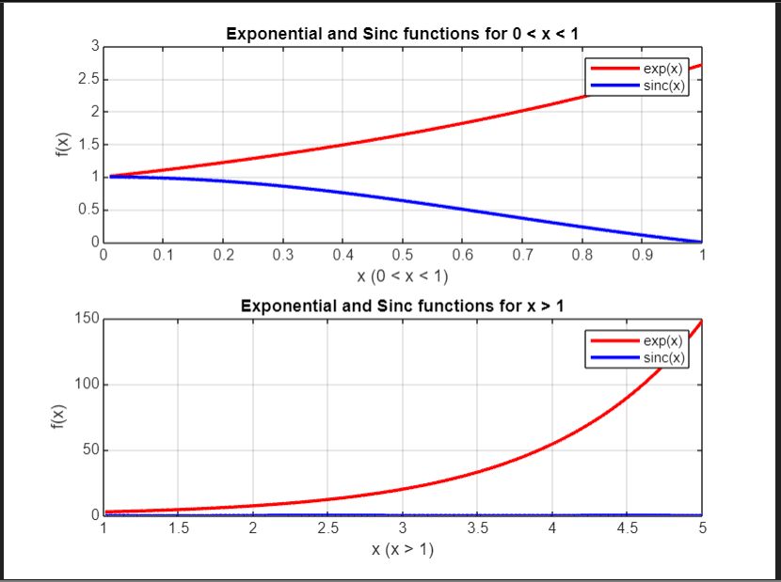

Shifting and Scaling of Function W.r.t Dependent and Independent Axis

clear all

close all

clc

% Define the original signal

x = linspace(-1, 1, 100); % independent axis S1

y = sqrt(1 - (x.^2)); % dependent axis S1

a = linspace(2, 4, 100); % independent axis S2

b = sqrt(1 - (a - 3).^2); % dependent axis S2

c = linspace(1, 1.5, 25); % independent axis S3

y1 = 2 .* (1 - c); % dependent axis S3

d = linspace(1.5, 2, 25); % independent axis S4

y2 = (d - 2) ./ 0.5; % dependent axis S4

% Concatenate the segments

z1 = [x, c]; % independent axis S1+S2

z2 = [z1, d]; % independent axis (S1 + S2) + S3

z = [z2, a]; % independent axis (S1 + S2 + S3) + S4

q1 = [y, y1]; % dependent axis S1 + S2

q2 = [q1, y2]; % dependent axis (S1 + S2) + S3

q = [q2, b]; % dependent axis (S1 + S2 + S3) + S4

% Plot the original signal x(t)

subplot(4, 2, [1 2])

plot(z, q);

title("Original signal x(t)");

xlim([-1 4]);

ylim([-2 2]);

grid on;

% Plot x(2t) - time compression

subplot(4, 2, 3)

plot(z .* 0.5, q);

title("x(2t)");

xlim([-1 4]);

ylim([-2 2]);

grid on;

% Plot x(t+2) - time shift to the left by 2

subplot(4, 2, 4)

plot(z - 2, q);

title("x(t+2)");

xlim([-4 4]);

ylim([-2 2]);

grid on;

% Plot 2x(t) - amplitude scaling

subplot(4, 2, 5)

plot(z, 2 .* q);

title("2x(t)");

xlim([-1 4]);

ylim([-2 2]);

grid on;

% Plot x(t) + 2 - vertical shift

subplot(4, 2, 6)

plot(z, q + 2);

title("x(t) + 2");

xlim([-1 4]);

ylim([-4 4]);

grid on;

% Plot x(-t) - time reversal

subplot(4, 2, 7)

plot(-z, q);

title("x(-t)");

xlim([-4 4]);

ylim([-2 2]);

grid on;

% Plot -x(t) - amplitude reversal

subplot(4, 2, 8)

plot(z,-q);

title("-x(t)");

xlim([-1 4]);

ylim([-2 2]);

grid on;

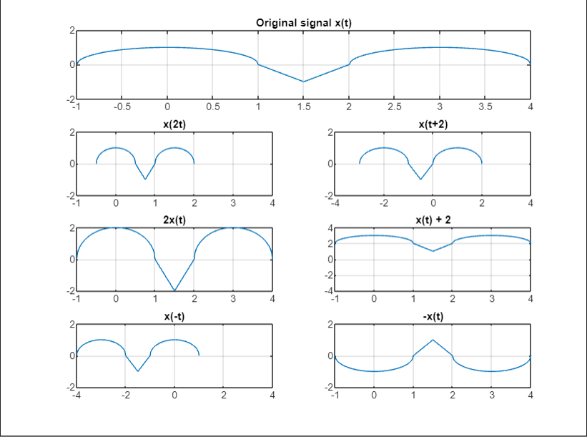

Shifting and Scaling of given Function W.r.t Dependent and Independent Axis

clear all;

close all;

clc;

% Define time axis

t = linspace(-10, 10, 1000); % Time vector

x_t = sin(t); % Original function x(t) = sin(t)

% Create figure with subplots for each transformation

figure;

% x(2t) - Time compression

subplot(5, 2, 1);

plot(t, sin(2 * t));

title('x(2t)');

xlabel('t');

ylabel('Amplitude');

grid on;

% x(0.5t) - Time expansion

subplot(5, 2, 2);

plot(t, sin(0.5 * t));

title('x(0.5t)');

xlabel('t');

ylabel('Amplitude');

grid on;

% 3x(2t) - Time compression with amplitude scaling

subplot(5, 2, 3);

plot(t, 3 * sin(2 * t));

title('3x(2t)');

xlabel('t');

ylabel('Amplitude');

grid on;

% 3x(0.5t) - Time expansion with amplitude scaling

subplot(5, 2, 4);

plot(t, 3 * sin(0.5 * t));

title('3x(0.5t)');

xlabel('t');

ylabel('Amplitude');

grid on;

% x(2t + 3) - Time shift with compression

subplot(5, 2, 5);

plot(t, sin(2 * t + 3));

title('x(2t + 3)');

xlabel('t');

ylabel('Amplitude');

grid on;

% x(0.5t + 3) - Time shift with expansion

subplot(5, 2, 6);

plot(t, sin(0.5 * t + 3));

title('x(0.5t + 3)');

xlabel('t');

ylabel('Amplitude');

grid on;

% 4x(0.5t - 3) - Amplitude scaling, time shift, and expansion

subplot(5, 2, 7);

plot(t, 4 * sin(0.5 * t - 3));

title('4x(0.5t - 3)');

xlabel('t');

ylabel('Amplitude');

grid on;

% -2x(-3t - 4) - Amplitude reversal, time reversal, scaling, and shift

subplot(5, 2, 8);

plot(t, -2 * sin(-3 * t - 4));

title('-2x(-3t - 4)');

xlabel('t');

ylabel('Amplitude');

grid on;

% -2x(-3(t - 2)) - Time and amplitude reversal, scaling with shift

subplot(5, 2, 9);

plot(t, -2 * sin(-3 * (t - 2)));

title('-2x(-3(t - 2))');

xlabel('t');

ylabel('Amplitude');

grid on;

% -2x(-3(t + 2) + 2) - Complex transformation

subplot(5, 2, 10);

plot(t, -2 * sin(-3 * (t + 2) + 2));

title('-2x(-3(t + 2) + 2)');

xlabel('t');

ylabel('Amplitude');

grid on;

% Adjust figure layout for readability

sgtitle('Modifications of x(t) = sin(t)');

